Prompt 1:
Create a C++ Program with the following requirements. First make the input loop requirement.
The requirements for the main code are as follows.
C++

// Returns true if a valid address was found, false otherwise.
// On success: outAddress holds the 32-bit value,
// and outPort holds the port number, or -1 if no port was present.
// On failure: outAddress is set to 0 and outPort is set to -1.
bool extractIPv4(const std::string& str, unsigned long& outAddress, int& outPort);

Built-in functions/libraries you may not use
Any string-to-number conversion function: atoi, atol, atoll, strtol, strtoul, strtod, stoi, stol, stoul, sscanf, scanf with numeric conversions.
Any address-parsing library function: inet_aton, inet_pton, inet_addr, or equivalents.
Any regular-expression facility (std::regex, POSIX regex.h, or similar) — the parsing and validation logic must be your own character-by-character code, not a pattern matched by a library.
Standard character-classification functions (isdigit, etc.) are fine to use.
Other requirements
Exactly one valid address may be extracted per input line; everything else in the line is either garbage (skipped) or part of a candidate token that fails validation.
Reject anything that does not exactly match the grammar above — wrong octet count, empty octet, out-of-range octet or port, a disallowed leading zero, a second colon, a colon not immediately after the fourth octet, or a stray period/colon directly adjacent to an otherwise-valid address.
On success, print: Extracted IPv4 address: A.B.C.D (decimal value: N, port: P) where N is the 32-bit decimal value and P is the port number or the literal text none.

Here are the requirements for the input loop:
Input loop: main continuously prompts the user for input until the user enters END (case-sensitive), then prints Program terminated. and exits.

Here is some example input on how the code should function:
Enter a string (or 'END' to quit): connecting to 192.168.1.1 now
Extracted IPv4 address: 192.168.1.1 (decimal value: 3232235777, port: none)
Enter a string (or 'END' to quit): server=10.0.0.255:8080end
Extracted IPv4 address: 10.0.0.255 (decimal value: 167772415, port: 8080)
Enter a string (or 'END' to quit): 192a168.1.1.1
Extracted IPv4 address: 168.1.1.1 (decimal value: 2818638081, port: none)
Enter a string (or 'END' to quit): 192.168.1.1.
Invalid input: no valid IPv4 address found
Enter a string (or 'END' to quit): Connection from 192.168.1.1 refused
Extracted IPv4 address: 192.168.1.1 (decimal value: 3232235777, port: none)
Enter a string (or 'END' to quit): 192.168.01.1
Invalid input: no valid IPv4 address found
Enter a string (or 'END' to quit): 1.2.3.4:99999
Invalid input: no valid IPv4 address found
Enter a string (or 'END' to quit): 12.34.56
Invalid input: no valid IPv4 address found
Enter a string (or 'END' to quit): no number here
Invalid input: no valid IPv4 address found
Enter a string (or 'END' to quit): END
Program terminated.
Create the input loop requirement so that I can test it personally. Do not implement the other parts of the code yet.

Modifications: Added a feature so that a failed read is treated the same as the END command to make it easier for me to test if it breaks.
Prompt 2:
Implement the extraction function but do not pass it to main yet. The requirements are the same as previously described.
Prompt 3:
Now integrate it with the main function so the code will run in its entirety. Ensure for the display that main receives the result from extractIPv4 and formats the output exactly as specified previously.

Manual Testing: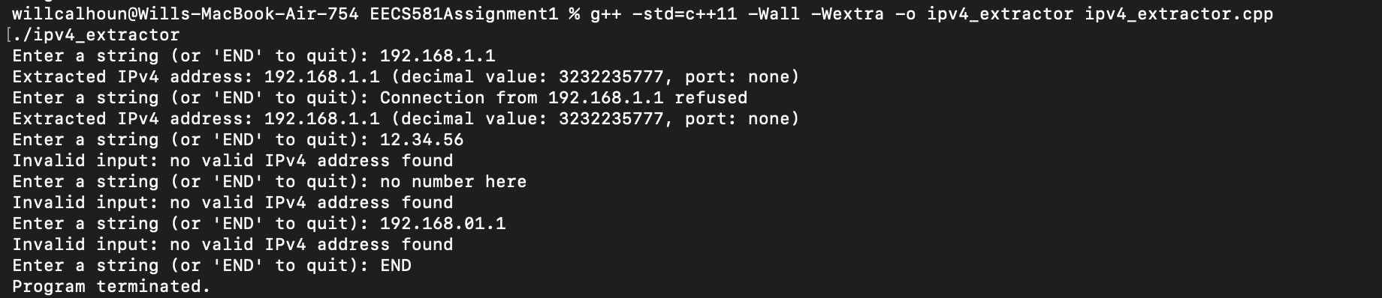

Verification Statement:
I understand each part of the code, even though most of it was generated by Claude Opus 5 using High thinking mode.
The code has been manually tested by me, as shown above.
I haven’t encountered any bugs yet, even after additional testing. Unexpected behavior was not seen but if any arises it could be most likely fixed easily.

